spring 2025
Cse-4377 wireless communication systems
the university of texas at arlington


lab 5 report
Submitted toward the partial completion of the requirements for CSE 4377
Under the guidance of
Prof. Jason Losh
By:
Joshua Martinez, 1001374818

Introduction
This lab revolves around the topic of signal propagation using three types of antennas tested within different environments. The three antennas, X-band horn antenna, 2.4 GHz Yagi-Uda antenna, and our created folded dipole, each utilizing a bandwidth with large difference apart from one another to demonstrate how they act within our environments. As with prior labs, necessary equipment setup and designated frequencies need to be within regulations for our lab usage. Overall, this lab should help illustrate the differences between frequency ranges, our chosen frequency, a VHF version from the Yagi-Uda, and a SHF with the X-horns, and their effectiveness with and without obstructions.

Steps 1-9: Equipment and Frequency Setup
The start of the lab requires receiving and understanding 2 additional antennas alongside our created folded dipole, a 2.4 GHz Yagi-Uda antenna and a pair of 8 GHz X-horn antennas. These three antennas, ours being set up for testing, can be seen in images one through 3 below. To power these antennas, an RF signal generator, frequency doubler, RF attenuators, Qorvo SBB5089Z LNA, PCB antennas, and an RF spectrum analyzer. The general setup for this lab is connecting one of the 3 transmitting antennas to the RF generator and the PCB antennas are connected to the analyzer with the center frequency needing to match the RF generator frequency with a span of 1 MHz. If a later received signal is too small to notice, the amplifier will be needed to boost the signal. Loss based on cable and connections, as shown by prior labs, will need to be measured and recorded to offset the total loss found during testing, shown later. For the X-horn, it will require the frequency doubler as the generator is limited to 4 GHz, creating the needed 8 GHz signal, as well as an attenuator on the analyzer side to help clarify the signal when reading. After connecting the equipment together with long enough cables and connectors, as the antennas need to be placed in certain areas around the lab, verifying the signals used with each transmitter are required and need to be approved with the TA. For the Yagi-Uda, it’s built for 2.4 GHz, barely above a restricted band, and can have periodic transmissions at 5000 uV/m at 3m. The X-horns are also barely within a safe range, 8 GHz barely underneath a restricted band, with the same periodic transmission value as the previous one. Our antenna has been made for a signal usage of 725 MHz, which is within a safe band with the same output values as the other two. The final step for setting the antennas is placing them in mounts, as shown in images below, where the X-horns require stools during testing and the others can use the “mast” bases in the lab to hold them up. After verifying everything that is set up properly and ready for testing, the next steps can be taken.

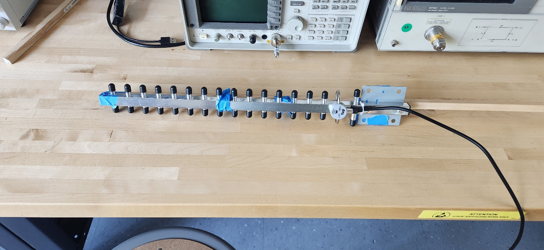

Image 1: 2.4 GHz Yagi-Uda antenna used for lab

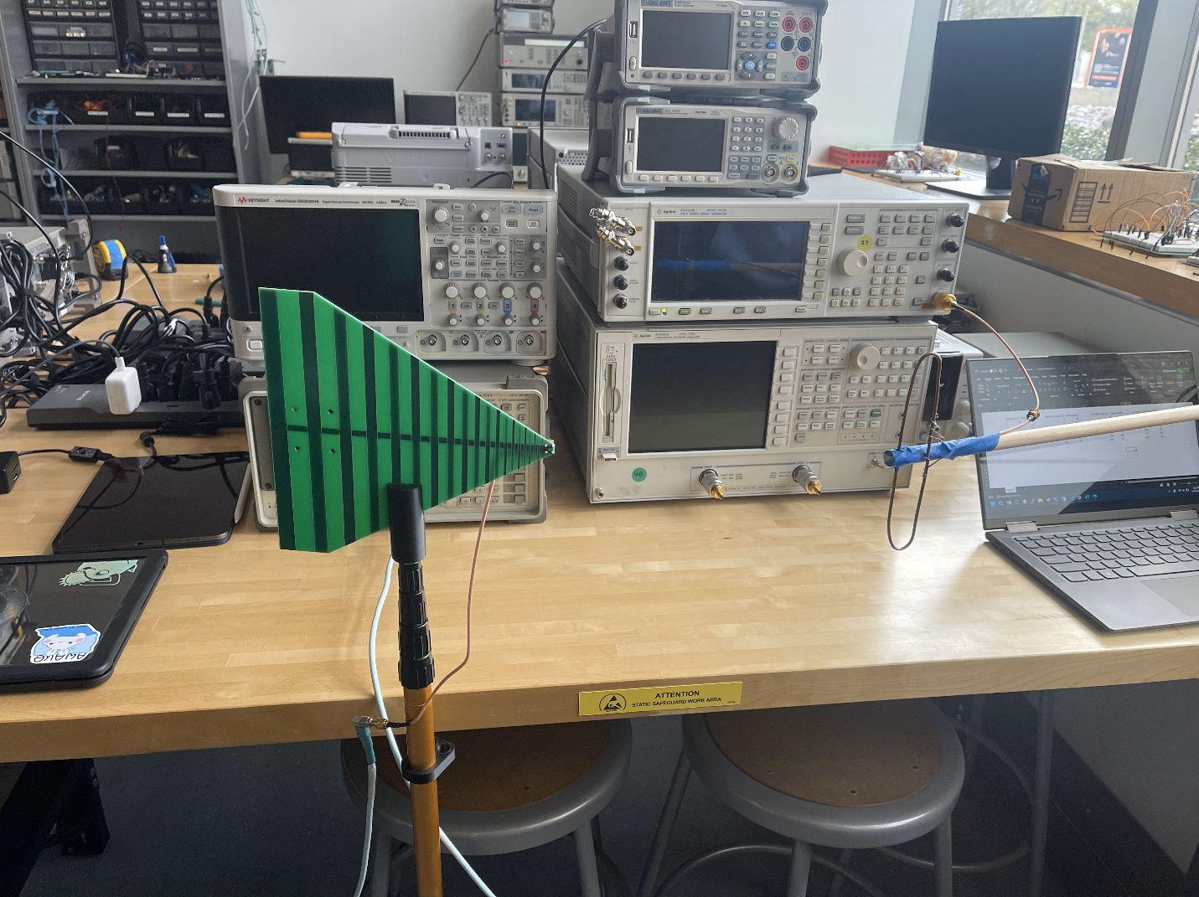

Image 2: Our built folded dipole w/ PCB antenna held via lab masts

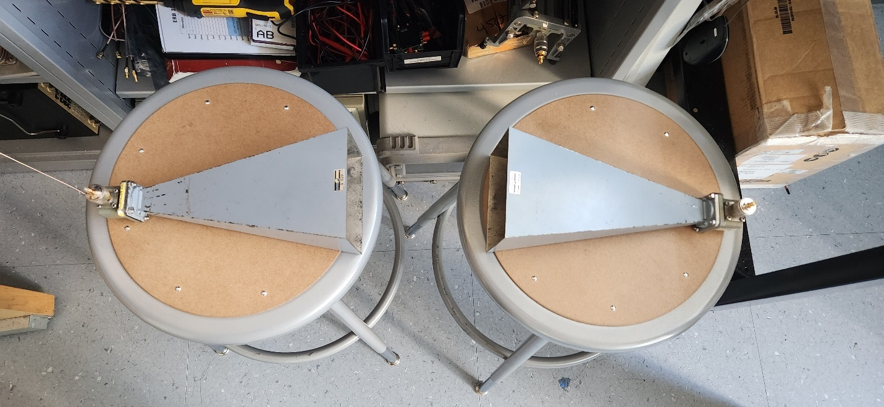
Image 3: X-Horn antenna on stools, used as masts during testing

Step 10 - 11: Antenna Testing – Free Space and Obstacles
After setup, the testing of the various transmitting antennas can start. For each, they are to be tested within close proximity in free space, or without obstructions. This will serve as the baseline for the X-band horns, Yagi-Uda, and our folded dipole antennas when we test various materials between the receiver and transmitters. The materials in the obstacles should induce some or major amounts of loss within the signal.
The first antenna we tested was our folded dipole, and table one below lists the data used to determine our baseline output of -23 dBm when operating this antenna to spec. The second table represents the measurements of the signal strength on the analyzer where there was open space, glass, wood, or a person between the transmitter and receiver antennas. Open space would be the baseline for testing as nothing would be obstructing the signal from reaching the other antenna when we placed them near inches from one another. When it comes to the glass wall, it was the thinnest thing we tested, and showed no signs of obscuring the signal. The last two objects were larger leading to a seemingly linear amount of loss. The four images below show captures of each of inputs based on the materials.
For the Yagi-Uda antenna, it was set up and tested similarly. The tables for this antenna listed our calculations for testing, but as this antenna was set up through another team, we used their layout which had an input of -20 dBm for the antenna instead. Regardless of this fact, we tested this antenna the same way with objects blocking the propagation of the signal. As can be seen from the table below, most signals found from this antenna received severe loss and were shown on the analyzer during testing as it showed a lot of noise with the signal coming through at times.
Lastly, for the X-band horns it was also set up by another team; thus, we tested with their setup to receive our data. The table below shows our calculations for these antennas to meet power output standards and for usage. From our discovery, the glass wall and the door had roughly the same effect on the signal after testing for a bit. However, when it comes to the other objects we placed between the horns, they had a far greater amount of loss experience. These sorts of materials seem to either absorb or reflect the signal greater than the other. After measuring these findings, conclude this section of the lab by helping illustrate potential signal loss from various and random objects.

Power (dBm) | -23.35
Distance (m) | 3
Gain (dBi) | 2.1
Power (W) | 4.62E-06
Area (m^2) | 113.1
PD (W/(m^2)) | 4.09E-08
R (ohms) | 377
Antenna Gain | 1.62
Max Power Density and E-Field Strength
PD (dBm/(m^2)) | -41.78
FS (uV/m) | 5000

Table 1: Calculation of power for our folded dipole antenna

Material | Power (dBm)
Baseline | -39.8
Glass | -38.21
Wood | -49.14
Person | -67.09

Table 2: Measurements of signal strength from folded dipole with various obstacles

Power (dBm) | -46.25
Distance (m) | 3
Gain (dBi) | 25
Power (W) | 2.3714E-08
Area (m^2) | 113.10
PD (W/(m^2)) | 2.097E-10
R (ohms) | 377
Antenna Gain | 316.23
Max Power Density and E-Field Strength
PD (dBm/(m^2)) | -41.78
FS (uV/m) | 5000

Table 3: Calculation of power for 2.4 GHz Yagi-Uda antenna

Materials | Power (dBm)
glass | -90
door | -87
wood block from mast stand | -85
Backpack | -91

Table 4: Measurements of signal strength from 2.4 GHz Yagi-Uda with various obstacles

Power (dBm) | -41.25
Distance (m) | 3
Gain (dBi) | 20
Power (W) | 7.4989E-08
Area (m^2) | 113.10
PD (W/(m^2)) | 6.631E-10
R (ohms) | 377
Antenna Gain | 100.00
Max Power Density and E-Field Strength
PD (dBm/(m^2)) | -41.78
FS (uV/m) | 5000

Table 5: Calculation of power for 8 GHz X-band horn antenna

Material | Power (dBm)
Glass | -61
Wooden Door | -61
Hand | -73
Backpack | -64

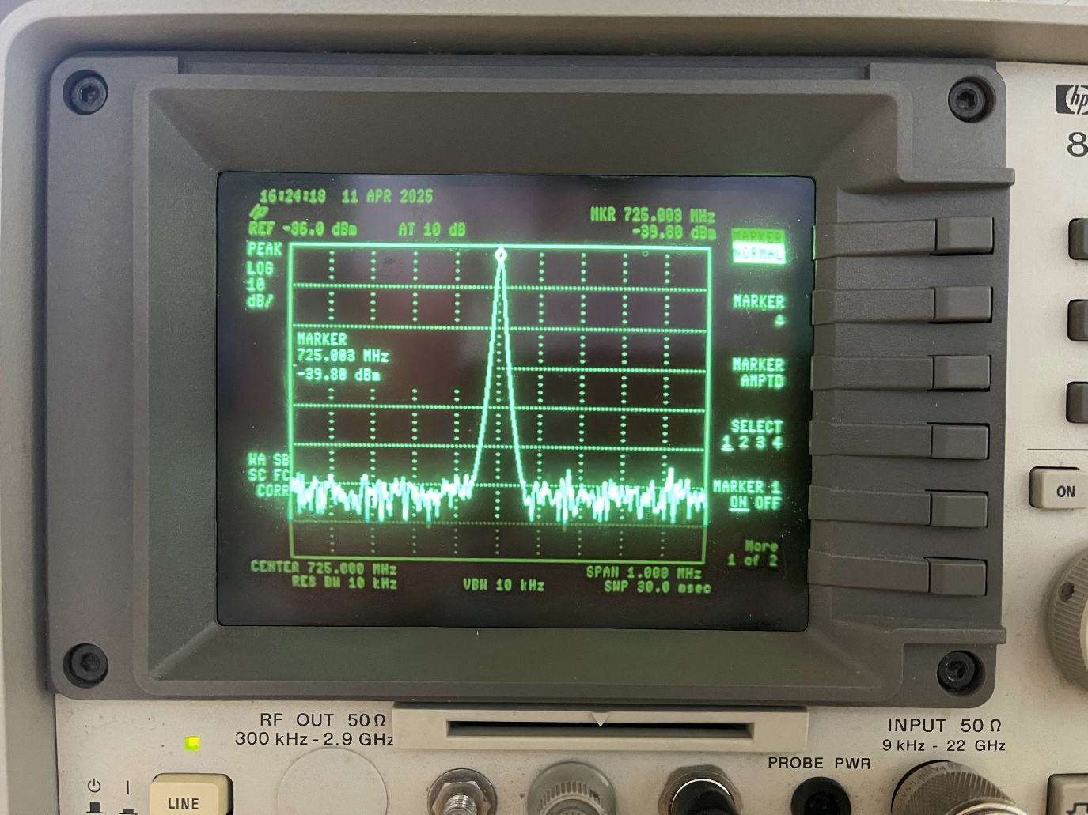
Table 6: Measurements of signal strength from 8 GHz X-band horn with various obstacles

Image 4: Captured signal of folded dipole in free space

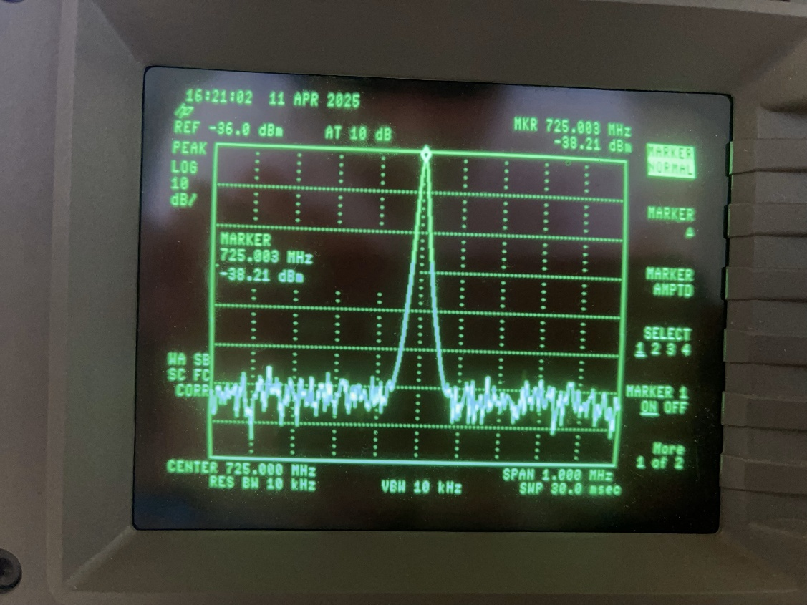
Image 5: Captured signal of folded dipole obstructed by glass wall

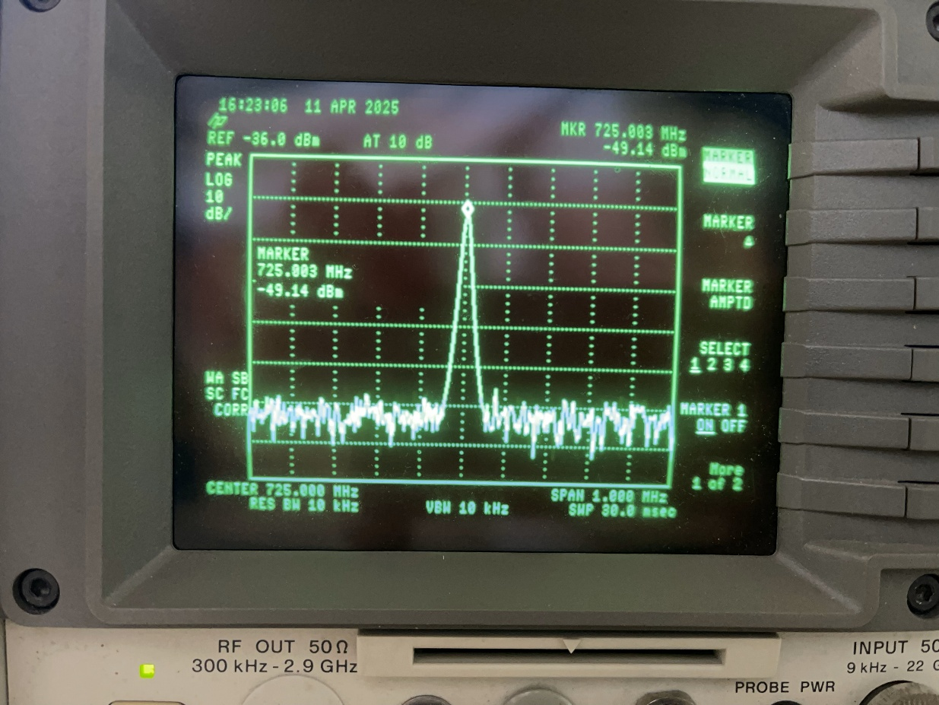

Image 6: Captured signal of folded dipole obstructed by wooden door
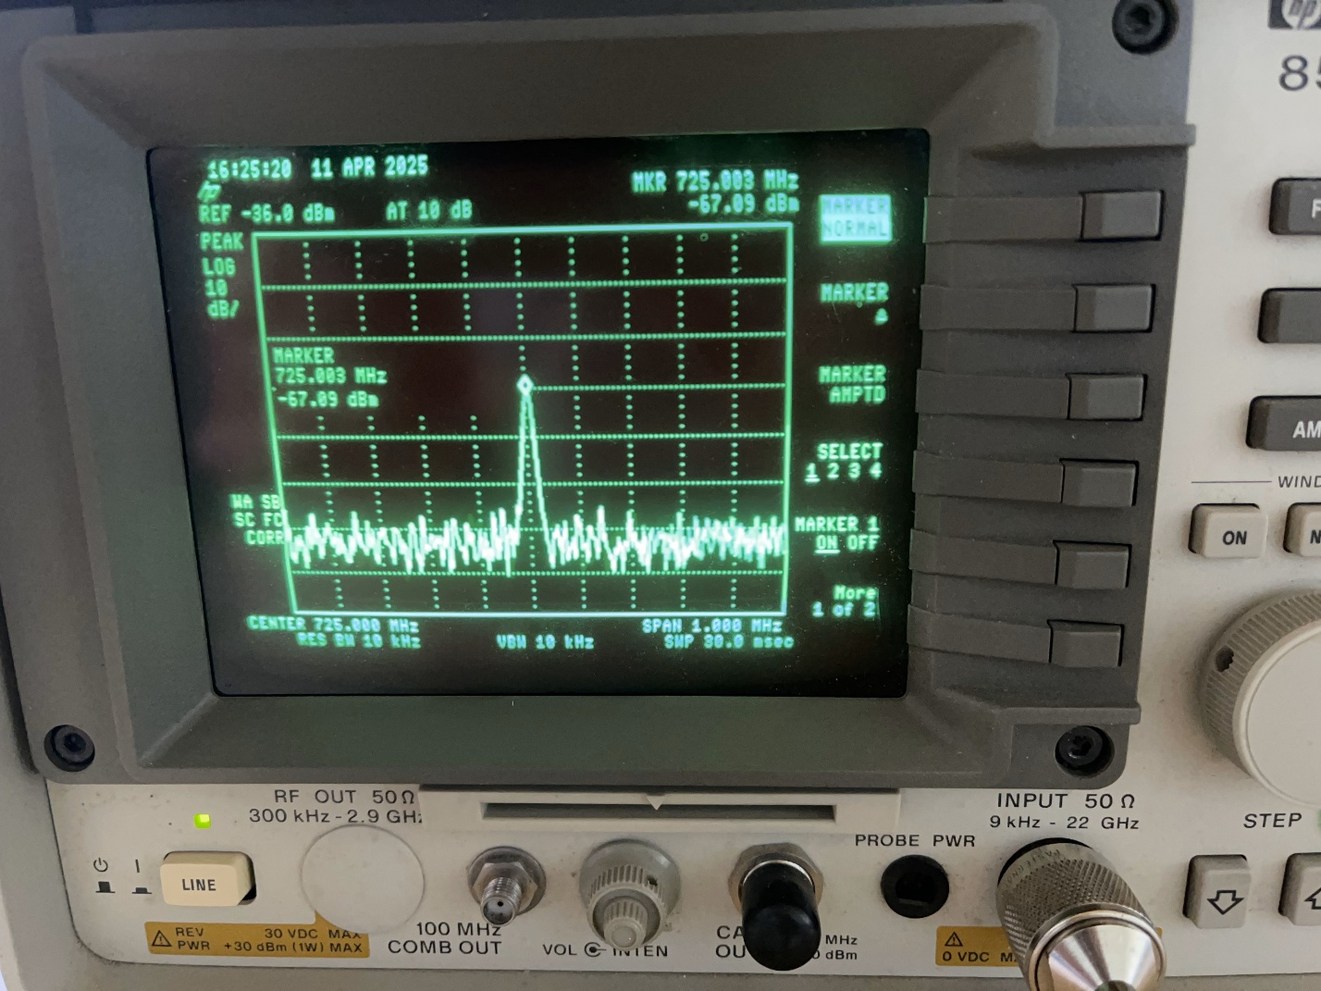
Image 7: Captured signal of folded dipole obstructed by a person

Step 12: Polarization loss – X-band Horns
The final step for the lab covers the polarization loss the X-band horns acquire based on the angle offset. For measuring this data, we revert the horns into facing each other as in the original state; afterwards, by an increment of 5, we increase the amount of offset the horns experience until the results become too severe to receive. Results of this test can be seen on the table below. At a certain point, the horns received data could not be discerned from noise. Although the horns have a narrow beam when it transmits a signal, the distance used to test the horns probably skewed our recorded data.

Angle Offset | Output dBm
0
5 | -61.2
10 | -65
15 | -71
20 | -73

Table X: X-Band horn dBm based on angle offset

Conclusion
To wrap up, this lab covers signal propagation through different antennas and frequencies and the effects the signals go through between open space and obstacles. With our antenna using 725 MHz, it experienced less loss during transmission and in all stages of testing. Minimal loss occurs with objects, such as glass or wooden doors, between the folded dipole and PCB antenna. The same could not be said of the X-horns and the Yagi-Uda. The X-horns experience great loss during open space, and more so with obstacles. The other antenna had minor loss in free space, but it became difficult to acquire a signal with solid obstacles in its path. In other words, larger wavelengths traverse through objects easier than smaller ones. Smaller wavelengths will incur major loss when going through specific materials. Overall, signals propagating through objects may incur larger loss than others relative to their wavelengths.

